**Project Creation –**

Simple Maven Project; and then add Spring Dependencies at POM.xml to make it a Spring Implementation.

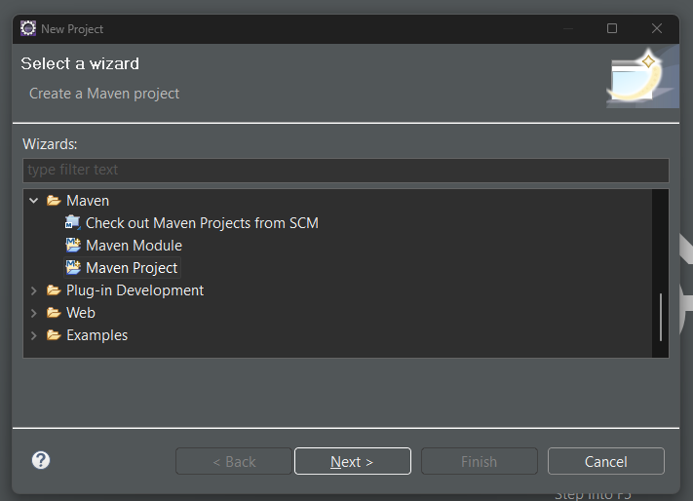

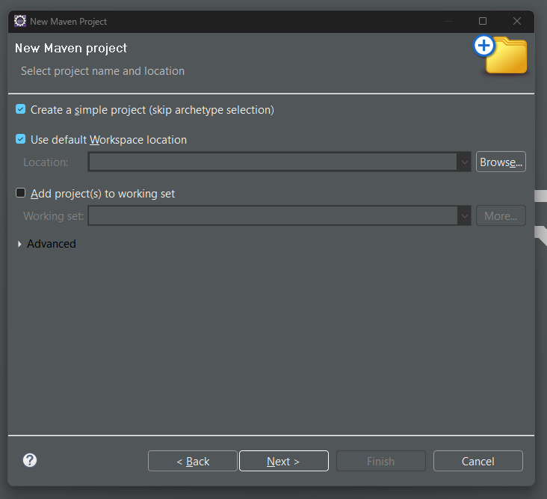

Spring MVC Setup

Add applications.proprties file at src/main/resources folder

Mention below attributes as view resolver:

spring.mvc.view.prefix: /WEB-INF/views/

spring.mvc.view.suffix: .jsp

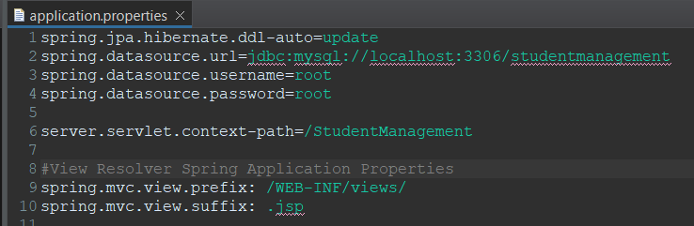

Building the code before execution:

Go to pom.xml 🡪 context menu 🡪 Run As 🡪 Maven Install

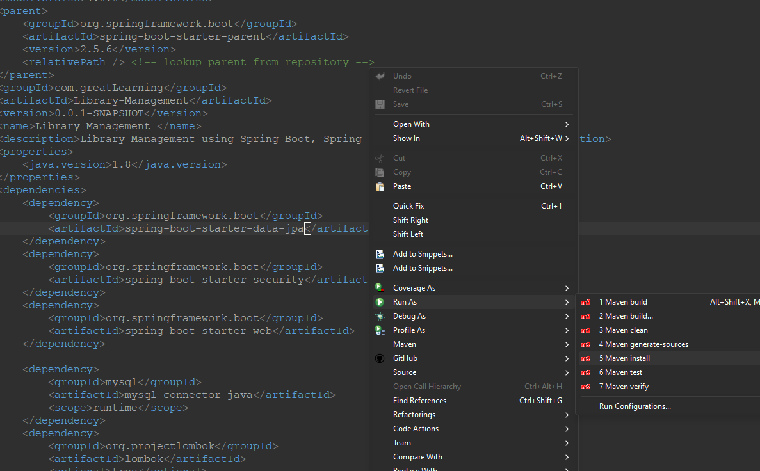

Database Setup:

1. Create the database

> create database studentmanagement

1. User Table

Way 1: Insert the Username password at database level using insert query.

Decrypt the password at <https://bcrypt-generator.com/> before inserting

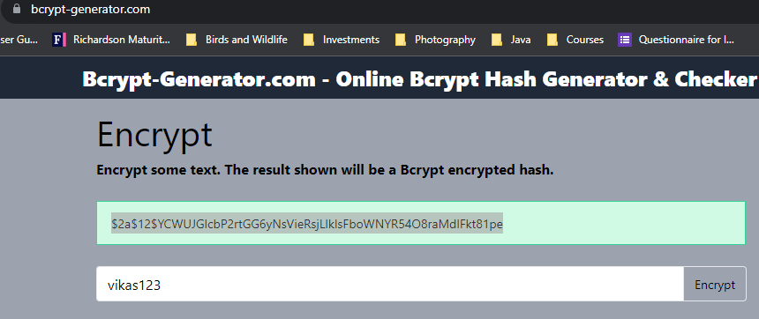

Table would look like this after Insert queries

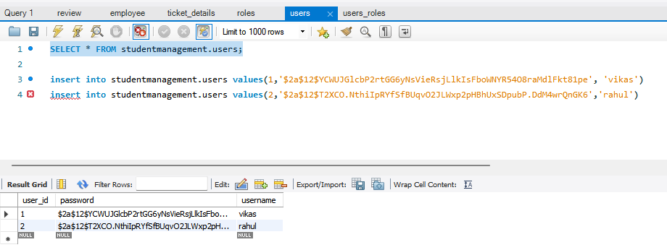

1. Role Table

Insert the entries manually using query

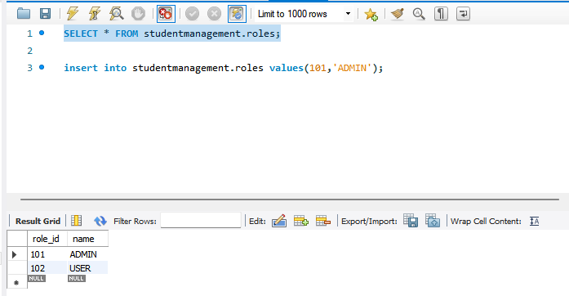

1. Users-roles table

Based on the User Id and Role ID inserted at above tables, accordingly insert the entries into this table for role assignment to the respective user

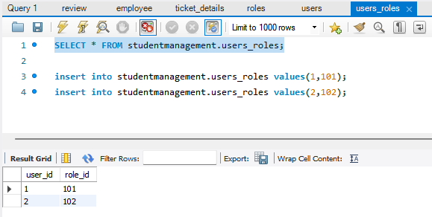

Screenshots

ADMIN User Login

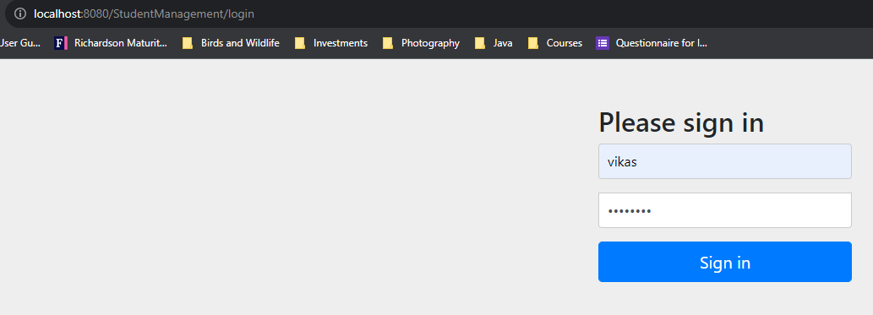

No Records present

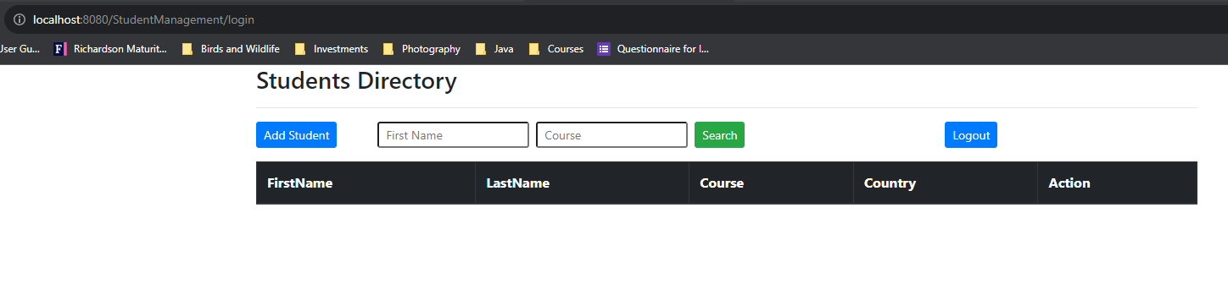

Add few records

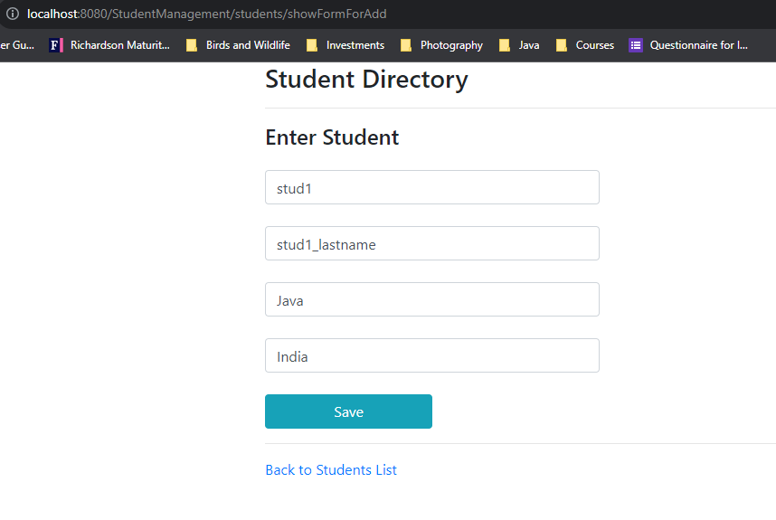

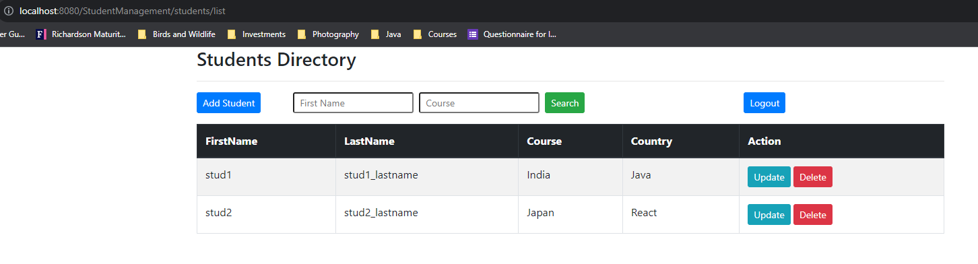

Admin can Update

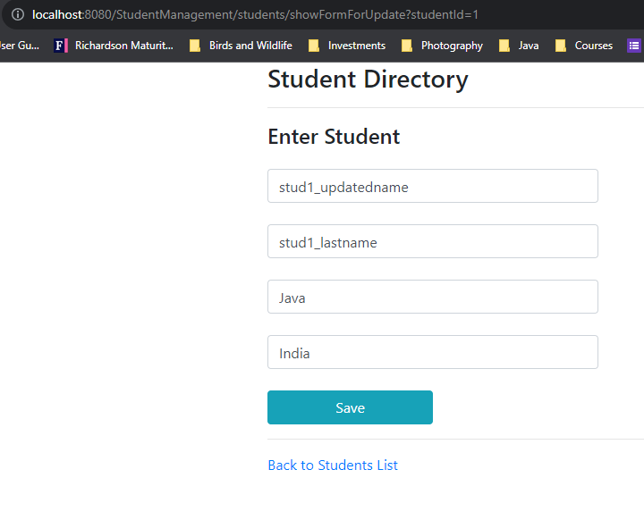

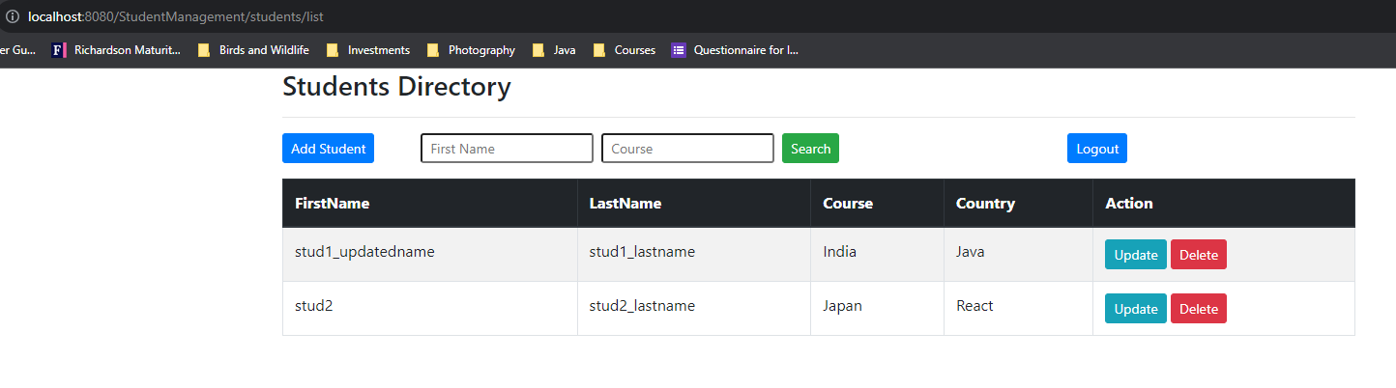

USER Login

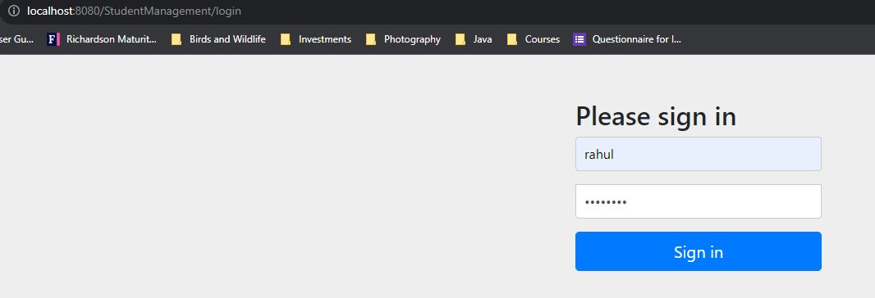

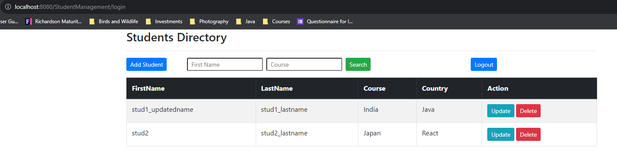

Clicked on Delete option

